National Change of Address (NCOA) Integration

Description
The NCOA Integration component will provide a mechanism to update the Enterprise Database with Addresses that have been updated by some process, either by some outside vendor or by AFSCME. The updated Addresses are loaded into an intermediary table by this outside process. Only the processing of the Addresses from the intermediary table to the rest of the Enterprise Database is in the scope of this component. The initial export of the Addresses and the loading of the intermediary table are outside the scope of this component. (See Outstanding Issues in the next section for more information.)

Requirements Input and Analysis
This component will process Addresses that have been updated by some NCOA process and are stored in an intermediary table. It will evaluate if a new Address needs to replace the existing address based on rules defined in the Processing Notes section below.

Input: Request from AFSCME initiating the update process

Output: Updates to the Enterprise Database; email to designated user

Dependencies: JMS Queue, FTP Server, Enterprise Database, SMTP Server, DTS Load Procedure

Outstanding Issues:
- The original requirements only state to send the System Mailing Address, but the System needs to track the original source address, so that if the returning NCOA address has one of four transaction codes indicating that the address was bad, the original source will need to marked as ‘Bad’.

Processing notes:
- AFSCME is responsible for retrieving the addresses, updating them, and loading them into the intermediary table prior to initiating the NCOA processing. See the Concept of Operations document for details on how this process will need to be performed.
- At this time, the following assumption will be followed:
  - The information needed in the intermediary table will need to contain the same information found in the file used by the current legacy process. The file structures can be seen in Appendix A.

Business Rules:
The following rules will be applied to each address for processing:
- If the NCOA Address has a Transaction Code of ‘E’, ‘G’, ‘K’ or ‘P’:
  - Update the NCOA Source with the NCOA Address marking it as ‘Bad’.
  - Update the original source with the NCOA Address marking it as ‘Bad’.
- If the NCOA Address has a Transaction Code of ‘A’, ‘M’, ‘S’ or ‘Z’:
  - Update the NCOA Source with the NCOA Address.
  - If the System Mailing Address has not changed since it was sent for NCOA processing, (need to determine how to evaluate this) do the following:
    - Check if the NCOA Address is qualified to be the System Mailing Address. (See rules under the System Mailing Address component for determining this.) If it is qualified, update the System Mailing Address with the NCOA Address.
- All Address changes and errors must be logged to an activity table.

Additional Requirements Information:

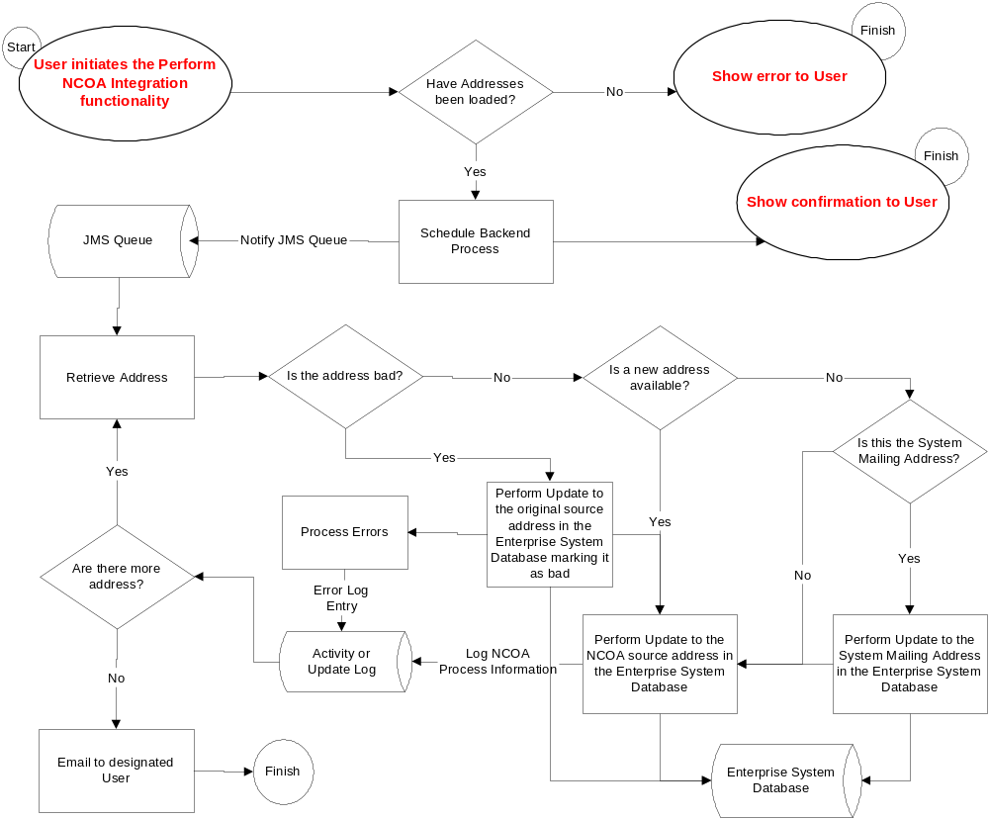
Figure 1 - National Change of Address (NCOA)

